Solution to 2018 Paper A

1. Multiple Choice (2 points for each, 16 points in total)
1-1 A room has two walls made of concrete, one wall made of steel, and one wall made of glass. All of the walls are the same size and at the same temperature of 20℃. Which wall feels coldest to the touch?
(A) the concrete wall;
(B) the steel wall;
(C) the glass wall;
(D) all the walls feel equally cold to the touch.

Answer: ()
when you touch one of the walls, heat flows from your hand to the lower-temperature wall. The more rapidly heat flows form your hand, the colder you will feel. So (B) the steel wall feels the coldest to the touch.

1-2 A quantity of gas containing N molecules has a speed distribution function 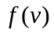. How many molecules have speeds between v1 and v2 (v2>v1 )?
(A) 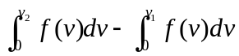;
(B) 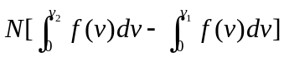;
(C) 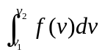;
(D) none of these.

Answer: ()

1-3 You have four samples of ideal gas, each of which contains the same number of moles of gas and has the same initial temperature, volume, and pressure. You compress each sample to one-half of its initial volume. Which sample has highest final pressure?
(A) a monatomic gas compressed isothermally;
(B) a monatomic gas compressed adiabatically;
(C) a diatomic gas compressed isothermally;
(D) a diatomic gas compressed adiabatically.

Answer: ()
Samples (A) and (C) are compressed isothermally, so PV = constant. The volume of each sample decreases to one-half of its initial value, so the final pressure is twice the initial pressure.
By contrast, samples (B) and (D) are compressed adiabatically, so 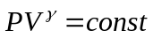 and the pressure increases by a factor of 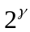.
Sample (B) is a monatomic gas for which 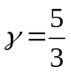, so its final pressure is 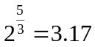 times greater than the initial pressure.
Sample (D) is a diatomic gas for which 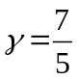, so its final pressure is greater than the initial pressure by a factor of 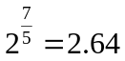

1-4 Which of the following heat engines has highest thermal efficiency.
(A) an engine that in one cycle absorbs 5000 J of heat and rejects 4500 J of heat;
(B) an engine that in one cycle absorbs 25,000 J of heat and does 2000 J of work;
(C) an engine that in one cycle does 400 J of work and rejects 2800 J of heat.

Answer: ()
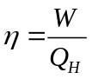 and 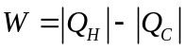.
For engine (A) W = 500 J and η= 500/5000 = 0.1
For engine (B) Q_{H} = 25000 J and W=2000J, soη= 2000/25000 = 0.08
For engine (C) W=400 J and Q_{C}= -2800 J, so Q_{H} = W-Q_{C} = 3200J andη= 400/3200 = 0.125

1-5 To double the total energy for a mass-spring system oscillation in SHM, by what factor must the amplitude increase?
(A) 4;
(B) 2;
(C) 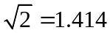;
(D) 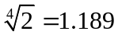.

Answers: ()
To increase the total energy E=1/2kA² by a factor of 2, the amplitude A must increase by a factor of .

1-6 A block attached to a hanging ideal spring oscillates up and down with a period of 10 s on earth. If you take the block and spring to Mars, where the acceleration due to gravity is only about 40% as large as on earth, what will be the new period of oscillation?
(A) 10 s;
(B) more than 10 s;
(C) less than 10 s.

Answer: ()
The oscillation period of a body of mass m attached to a hanging spring of force constant k is given by 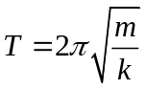, the same expression as for a body attached to a horizontal spring. Neither m nor k changes when the apparatus is taken to Mars, so the period is unchanged. The only difference is that in equilibrium, the spring will stretch a shorter distance on Mars than on earth due to the weaker gravity.

1-7 If you double the wavelength of a wave on a particular string, what happens to the wave speed u and the frequency f ?
(A) u doubles and f is unchanged;
(B) u is unchanged and f doubles;
(C) u becomes one-half as great and f is unchanged;
(D) u is unchanged and f becomes one-half as great.

Answer: ()
The speed of waves on a string, u, does not depend on the wavelength. We can rewrite the relationship u=λf as f=u/λ, which tells us that if the wavelength λ doubles, the frequency f becomes one-half as great.

1-8 You have been asked to compare four different proposals for telescopes to be placed in orbit, above the blurring effects of the earth’s atmosphere. Which of the proposed telescopes is best to resolve small details?
(A) a radio telescope 100 m in diameter observing at a wavelength of 21 cm;
(B) an optical telescope 2.0 m in diameter observing at a wavelength of 500 nm;
(C) an ultraviolet telescope 1.0 m in diameter observing at a wavelength of 100 nm;
(D) an infrared telescope 2.0 m in diameter observing at a wavelength of 10 μm.

Answer: ()
Rayleigh’s criterion combined with Eq. 36.17 shows that the smaller the value of the ratio λ/D, the better the resolving power of a telescope. For the four telescopes, this ratio is equal to
(A) 21 cm/100 m = 2.1×10⁻³;
(B) 500 nm /2.0 m =2.5×10⁻⁷;
(C) 100 nm/1.0 m = 1.0×10⁻⁷;
(D) 10 μm/2.0 m = 5.0×10⁻⁷.

2. Completion ( 3 points for each, 24 points in total)

2-1 A nail driven into a board increases in temperature. If we assume that 60% of the kinetic energy delivered by a 1.80-kg hammer with a speed of 7.80 m/s is transformed into heat that flows into the nail and does not flow out, the temperature increase of an 8.00-g aluminum nail after it is struck ten times is . For aluminum, specific heat c=0.91×10³ J/kg·K.

Solution:
The kinetic energy of the hammer before it strikes the nail is
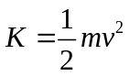
K=0.5×(1.8 kg)(7.80 m/s)²=54.8 J.
Each strike of the hammer transfers 54.8 J×60% = 32.9 J, and with 10 strikes Q=329 J
Q=mcΔT
So 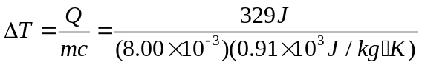=45.2℃

2-2 You kick a soccer ball, compressing it suddenly to  of its original volume. In the process, you do 410 J of work on the air (assumed to be an ideal gas) inside the ball. What is the change in internal energy of the air inside the ball due to being compressed?

Solution:
Since the volume decrease, W is negative. Since the compression is sudden, Q = 0.
ΔU = Q – W
Q = 0 gives ΔU = -W.
W<0 so ΔU >0.
ΔU = +410 J.

2-3 A Carnot engine whose low temperature reservoir is at -90.0℃ has an efficiency of 40.0%. An engineer is assigned the task of increasing this to 45.0%. By how many Celsius degrees must the temperature of the high temperature reservoir be increased if the temperature of the low temperature reservoir remains constant?

Solution:
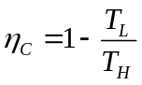, 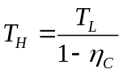 T_{L}= -90℃=183.16K
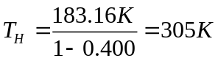
For η_{C}=45.0%, 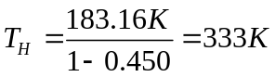,
T_{H} must be increased by 28K = 28℃.

2-4 You are watching an object that is moving in SHM. When the object is displaced 0.600 m to the right of its equilibrium position, it has a velocity of 2.20 m/s to the right and an acceleration of 8.40 m/s² to the left. How much farther from this point will the object move before it stops momentarily and then starts to move back to the left?

Solution:
Let +x be to the right. Let the mass of the object be m.
Since –kx=ma_{x},
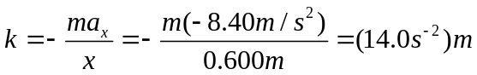
From conservation of energy 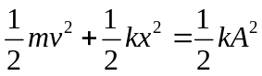, we have
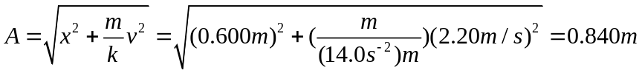
Therefore the object will travel 0.840 m-0.600 m=0.240 m to the right before stopping at its maximum amplitude.

2-5 A mass of 240 g oscillates on a horizontal frictionless surface at a frequency of 3.5 Hz and with amplitude of 4.5 cm. How much energy is involved in this motion?

Solution:
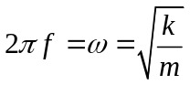, which gives
We find the total energy from the maximum potential energy:
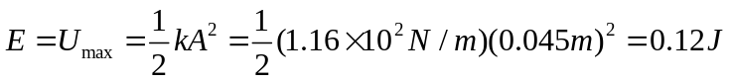

2-6 Two coherent sources A and B of radio waves are 5.00 m apart. Each source emits waves with wavelength 6.00 m. Consider points along the line between the two sources. At what distances, if any, from A is the interference destructive?

Solution:
Compare the path difference to the wavelength.
The separation between sources is 5.00 m, so for points between the sources the largest possible path difference is 5.00 m.
For destructive interference the path difference is
δ= (m+1/2)λ, m=0, ±1, ±2,…
Let A be the origin of the x axis.
For a point a distance x from A and 5.00-x from B, the path difference is δ= x-(5.00 m -x)
For m=0
δ= x-(5.00 m -x)=1/2λ
2x-5.00 m = +3.00 m gives x=4.00 m
2x-5.00 m = -3.00 m gives x=1.00 m
For m=1,δ= 3/2λ=9.00 m is not possible.

2-7 A plastic film with index of refraction 1.85 is put on the surface of a car window to increase the reflectivity and thus to keep the interior of the car cooler. The window glass has index of refraction 1.52. What minimum thickness is required if light with wavelength 550 nm in air reflected from the two sides of the film is to interfere constructively?

Solution:
The reflection at the top surface of the film produces a half-cycle phase shift. There is no phase shift at the reflection at the bottom surface.
For constructive interference, we have
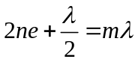, m=1, 2, 3…
The minimum thickness is 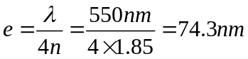

2-8 If you can read the bottom row of your doctor’s eye chart, your eye has a resolving power of
1 arcminute, equal to 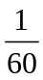degree. If this resolving power is diffraction limited, to what effective diameter of your eye’s pupil does this correspond? . Use Rayleigh’s criterion and assume the wavelength for the light λ=550nm.

Solution:
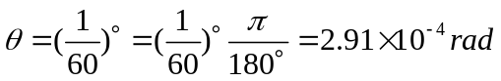
Since 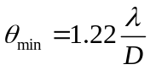
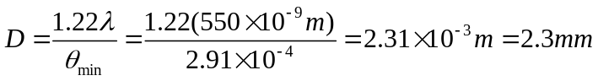

3. Calculation Problems (10 points for each, 60 points in total)

3-1 In very cold weather a significant mechanism for heat loss by the human body is energy expended in warming the air taken into the lungs with each breath. (a) On a cold winter day when the temperature is -20℃, what amount of heat is needed to warm the 0.50 L of air exchanged with each breath to body temperature (37℃)? Assume that the specific heat of air is 1020 J/kg·K and that 1.0 L of air has mass 1.3×10⁻³ kg. (b) How much heat is lost per hour if the respiration rate is 20 breaths per minute?

Solution:
(a)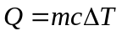
m = 0.5×1.3×10⁻³ kg = 0,65×10⁻³ kg
Q = (0.65×10⁻³ kg)(1020 J/kg·K)(37℃-(-20℃)) = 38 J
(b) 20 breaths/min (60 min/1 h) =1200 breaths/h
So Q=(1200)(38 J) = 4.6×10⁴ J
The heat loss rate is Q/t = 13 W

3-2 The surface of the sun has a temperature of about 5800 K and consists largely of hydrogen atoms. (a) Find the root mean square speed of a hydrogen atom at this temperature. The mass of a single hydrogen atom is 1.67×10⁻²⁷ kg. (b) Calculate the escape speed for a particle to leave the gravitational influence of the sun. the mass of the sun M=1.99×10³⁰ kg. Its radius R=6.96×10⁸ m, and the gravitational constant G=6.67×10⁻¹¹N·m²/kg². (c) Can appreciable quantities of hydrogen escape from the sun? Can any hydrogen escape?

Solution:
- 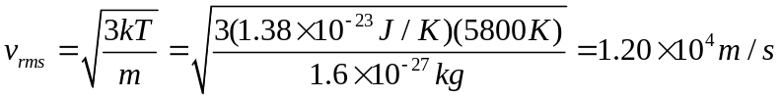
- 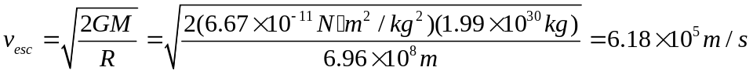
- The escape speed is about 50 times the root mean square speed, which indicate that there is a negligibly small fraction of molecules with the escape speed.

3-3 The power output of an automobile engine is directly proportional to the mass of air that can be forced into the volume of the engine’s cylinders to react chemically with gasoline. Many cars have a turbocharger which compresses the air before it enters the engine, giving a greater mass of air per volume. This rapid, essentially adiabatic compression also heats the air. To compress it further, the air then passes through an intercooler in which the air exchanges heat with its surroundings at essentially constant pressure. The air is then drawn into the cylinders. In a typical installation, air is taken into the turbocharger at atmospheric pressure (1.01×10⁵ Pa), density ρ= 1.23 kg/m³, and temperature 15.0℃. It is compressed adiabatically to 1.45×10⁵ Pa. (a) Draw a PV-diagram for this sequence of processes. (b) If the volume of one of the engine’s cylinders is 575 cm³, what mass of air exiting from the intercooler will fill the cylinder at 1.45×10⁵ Pa? Compared to the power output of an engine that takes in air at 1.01×10⁵ Pa at 15.0℃, what percentage increase in power is obtained by using the turbocharger and intercooler? (c) If the intercooler is not used, what mass of air exiting from the turbocharger will fill the cylinder at 1.45×10⁵ Pa? Compared to the power output of an engine that takes in air at 1.01×10⁵ Pa at 15.0℃, what percentage increase in power is obtained by using the turbocharger alone?
Solution:
M = ρV, and 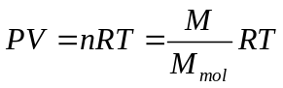
The density of air is given by 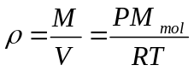
For an adiabatic process, 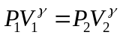 or 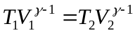
Using 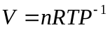, we have 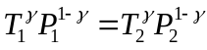
(a) The PV-diagram is sketched as follow
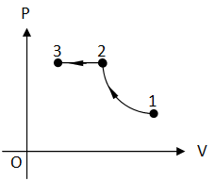
(b) The final temperature is the same as the initial temperature, and the density is proportional to the absolute pressure.
From , we have 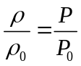
The mass needed to fill the cylinder is then
Without the turbocharger or the intercooler the mass of air at T=15.0℃ and P=1.01×10⁵ Pa in a cylinder is
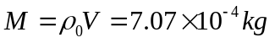
The increase in power is proportional to the increase in mass of air in the cylinder. The percentage increase is 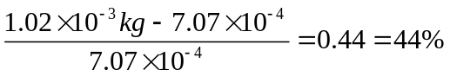
(c) From or 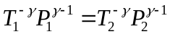 or 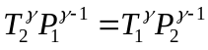
The temperature after the adiabatic process is
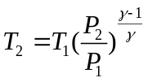
The density becomes
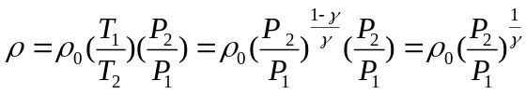
The mass of air in the cylinder is
The percentage increase in power is 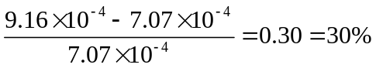
The turbocharger and intercooler each have an effect on the engine power.

3-4 A heat pump is a heat engine run in reverse. In winter it pumps heat from the cold air outside into the warmer air inside the building, maintaining the building at a comfortable temperature. In summer it pumps heat from the cooler air inside the building to the warmer air outside, acting as an air conditioner. (a) If the outside temperature in winter is -5.0℃ and the inside temperature is 17.0℃, how many joules of heat will the heat pump deliver to the inside for each joule of electrical energy used to run the unit, assuming an ideal Carnot cycle? (b) Suppose you have the option of using electrical resistance heating rather than a heat pump. How much electrical energy would you need in order to deliver the same amount of heat to the inside of the house as in part (a)? (c) Consider a Carnot heat pump delivering heat to the inside of a house to maintain it at 68℉. Show that the heat pump delivers less heat for each joule of electrical energy used to operate the unit as the outside temperature decrease. Notice that this behavior is opposite to the dependence of the efficiency of a Carnot heat engine on the difference in the reservoir temperature. Explain why this is so.

Solution:
(a) Work done by the electrical energy is W=1.00 J,
T_{L}= -5.0℃=268.16 K, and T_{H}=17.0℃=290.15 K
W=Q_{H}-Q_{L, 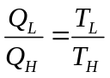,} 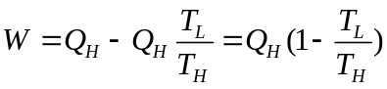
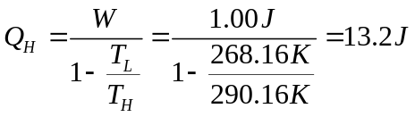
(b) By using an electrical resistance heater, electrical energy is converted directly into heat, so an electrical energy input of 13.2 J would be required.
(c) From 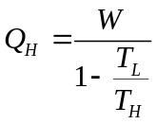, we can see Q_{H} deceases as T_{L} decrease. The heat pump is less efficient as the temperature difference through which the heat has to be “pumped” increases. In an engine, heat flows from T_{H} to T_{L} and work is extracted. The engine is more efficient the large the temperature difference through which the heat flows.

3-5 On a frictionless, horizontal air track, a glider oscillates at the end of an ideal spring of force constant 2.50 N/cm. The graph shows the acceleration of the glider as a function of time. Find (a) the mass of the glide; (b) the maximum displacement of the glider from the equilibrium point; (c) the maximum force the spring exerts on the glider.
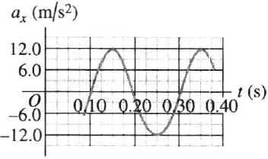
Solution:
(a) gives 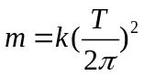. Spring constant is given by k = 2.50 N/cm =250 N/m.
We need to find period T.
Since 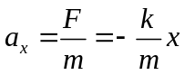, a_{x} is proportional to x. So a_{x} goes through one cycle when the displacement goes through one cycle. From the graph, one cycle of a_{x} extends from t=0.10 s to t=0.30 s, so the period is T=0.20 s.
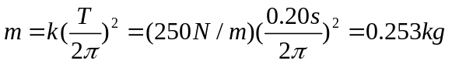
(b) 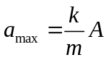. From the graph the maximum acceleration is 12.0 m/s².
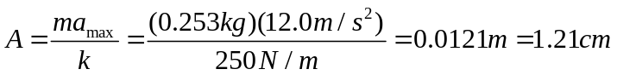
(c)
Or

3-6 A sinusoidal wave is propagating along a stretched string that lies along the x-axis. The displacement of the string as a function of time is graphed in following figure for particles at x=0 and at x=0.090 m. (a) What is the amplitude of the wave? (b) What is the frequency of the wave? (c) You are told that the two points x=0 and x=0.090 m are within one wavelength of each other. If the wave is moving in the +x direction, determine the wavelength and the wave speed. (d) What is the mathematical representation of this wave?
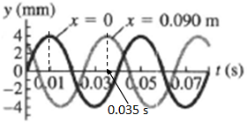

Solution:
(a) It can be read from the graph that A = 4 mm.
(b) Period T = 0.040 s. 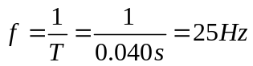
(c) The wave is traveling in +x direction, and x=0 and x=0.090 m are within one wavelength.
At t₁=0.010s the peat is at x=0. At t₂=0.035s, the peak moves to x=0.090 m
So 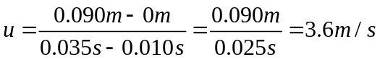
Wavelength 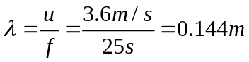
(d) since at t=0, the displacement y=0 for the particle at x=0, and for the next time this particle moves to a +y, so the initial phase angle Ф=-π/2. Therefore, we have
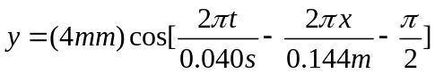, or

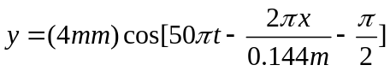

BBBCCADC

